Q1. ((ip.src == 192.168.1.2 && tcp.dstport == 21) || (ip.dst == 195.89.6.167 && (tcp.srcport == 20 || tcp.srcport == 21)))

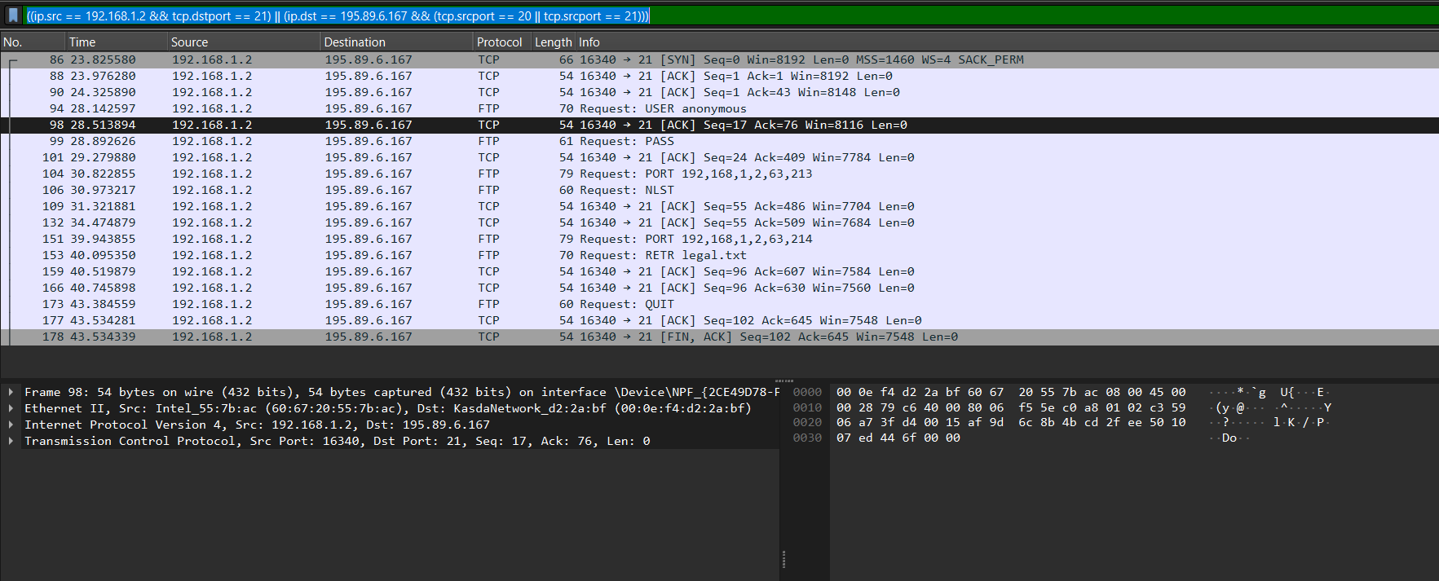

Q2. ((eth.src == 00:0e:f4:d2:2a:bf) && (!udp.dstport == 53))

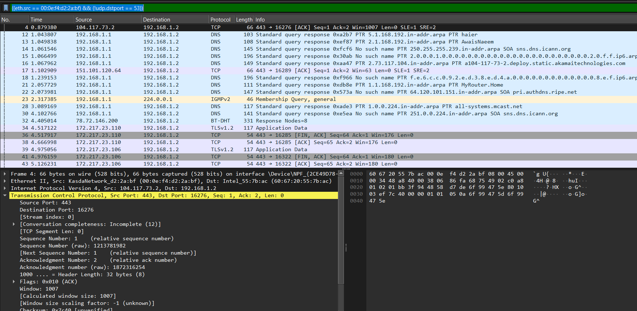

Q3. udp.srcport == 53 || udp.dstport == 53

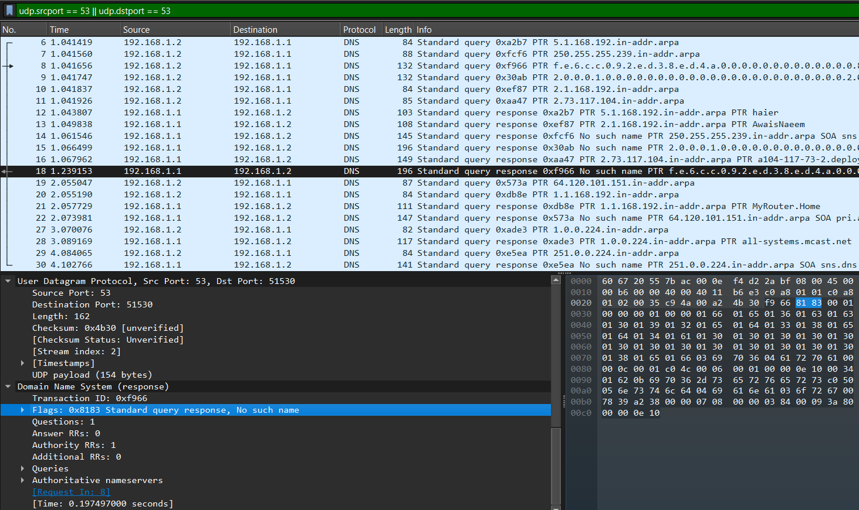

Acknowledgement number will be none since udp is connectionless?

Q4. udp && ip.addr contains 192.168.\*.\*